Clock pulse unit
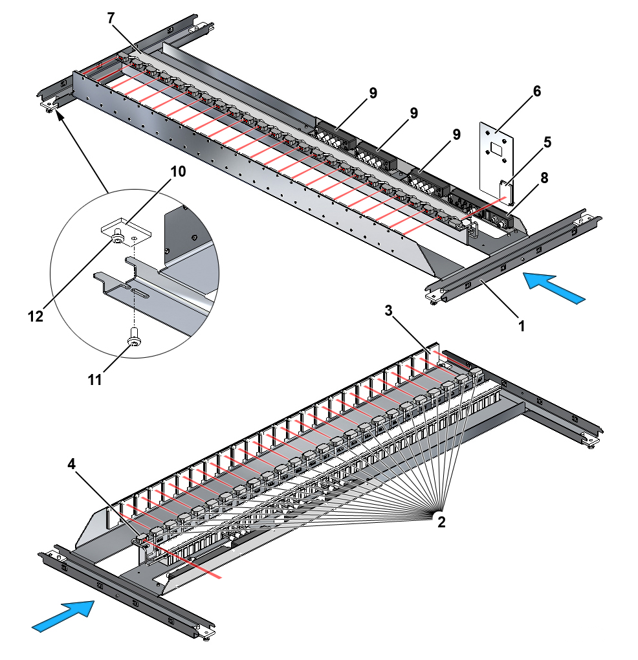
Fig. 1-1 Clock pulse unit, complete
1. | Bracket for clock pulse unit | 7. | Cable duct
2. | Clock pulse photocells | 8. | Profibus interface
3. | Reflector for clock pulse photocells | 9. | Digital input module
4. | Synchronization photocell | 10. | Fixing plate
5. | Reflector for synchronization photocell | 11. | Guide screw
6. | Reflector bracket | 12. | Fixing screw

Preparation necessary
Installation of the following parts of the sorter must be complete before the clock pulse unit is installed:
- Supports
- Sections

Tools
Part No. | Description | Qty
172A553 | Screwdriver bit holder ¼" | 1
172A552 | Bit set with 30 bits (Torx 10, 25, 45) | 1
161A239 | Torque wrench 8-60 Nm | 1
 | Reversible ratchet insert tool ¼" (Stahlwille 735/4) | 1
161A236 | Universal bit holder ¼" x ¼" | 1
161A403 | Combination wrench 5.5 mm | 1

Guides
- Electrical component location drawing
- Cable list for Profibus
- Cable list for 24 V supply
- Wiring diagram for “Clock Pulse Arrangement 1200 mm”

PREPARATION BEFORE INSTALLATION
The Profibus interface must be addressed before the clock pulse unit is installed.
.1 Undo the five screws securing the removable bracket for the interface and I/O modules as shown in Fig. 1-2.
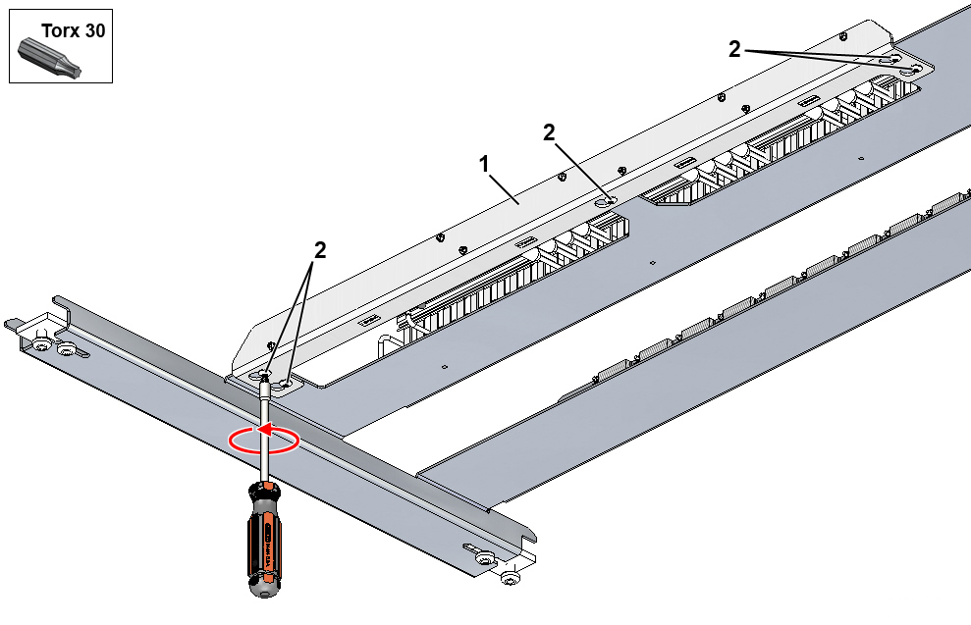
Fig. 1-2 Release of removable bracket for interface and I/O modules
1. | Removable bracket for interface and I/O modules
2. | Screw, Torx 30, M6x10

.2 Detach the removable bracket for interface and I/O modules and turn the bracket to provide access to the interface from above as shown in Fig. 1-3.
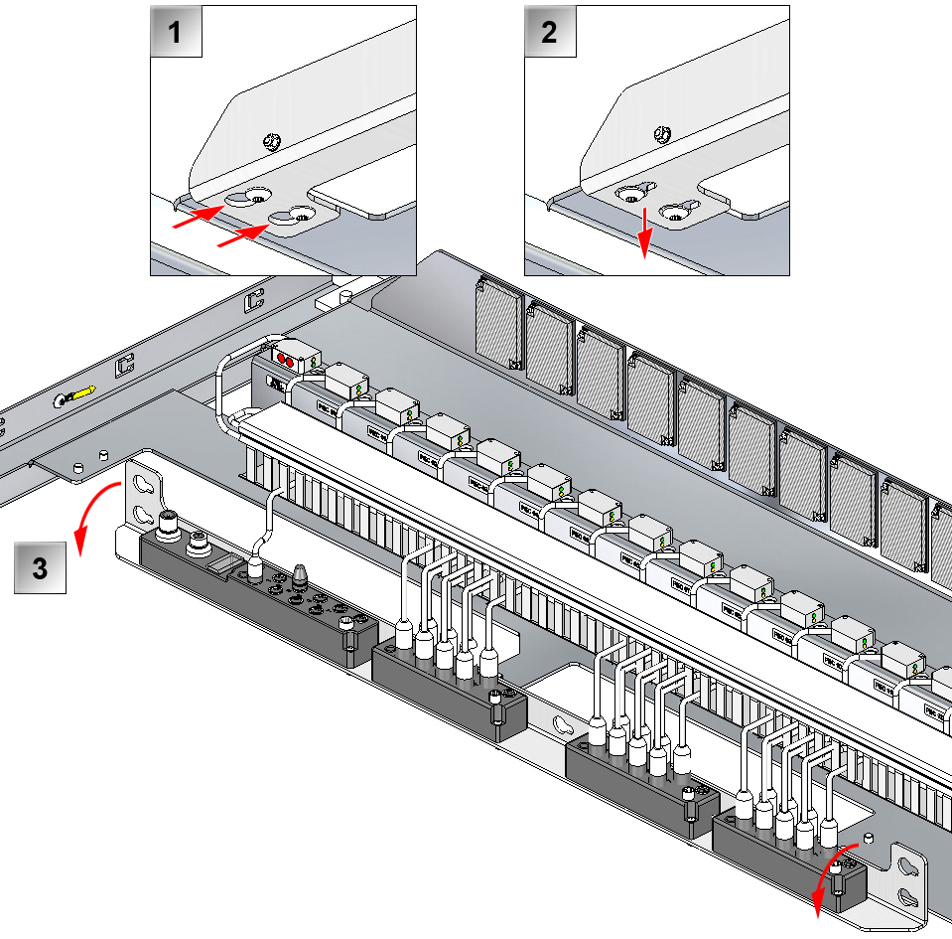
Fig. 1-3 Detaching removable bracket for interface and I/O modules

.3 Address the Profibus interface as described in chapter .
.4 Reattach the removable bracket for interface and I/O modules.
.5 Tighten the five screws securing the removable bracket for interface and I/O modules as shown in Fig. 1-2.

Installation guide

Installation of clock pulse unit
.1 Position the clock pulse unit on the mounting flanges of the cable trays in the sorter frame in accordance with the electrical component location drawing.
.2 The clock pulse unit is delivered on site in the form of a pre-assembled unit. Profibus connectors are supplied in a separate bag attached to the clock pulse unit.
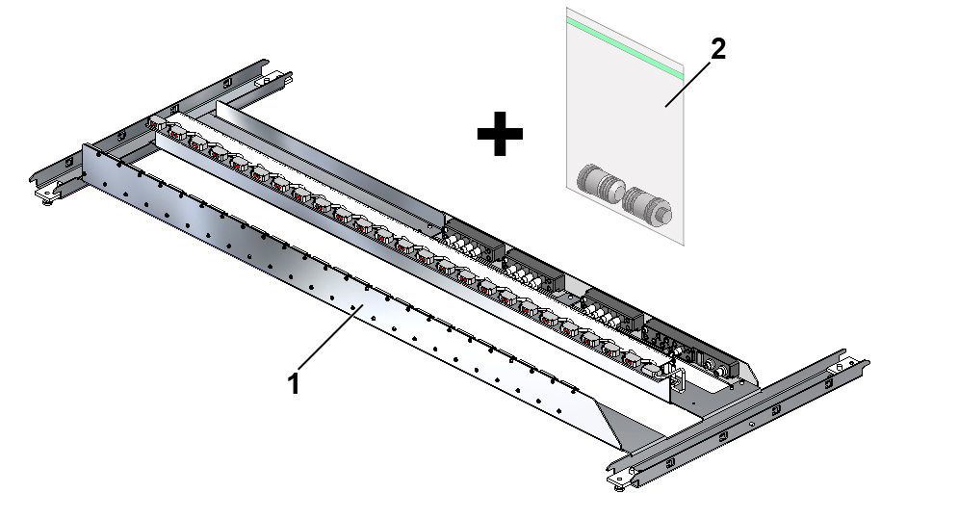
Fig. 1-4 Clock pulse unit, as delivered on site
1. | Clock pulse unit, complete
2. | Separate bag containing Profibus connectors, male and female

.3 Prepare the clock pulse unit for installation by pushing the four fixing plates towards the middle of the clock pulse unit as shown in Fig. 1-5.
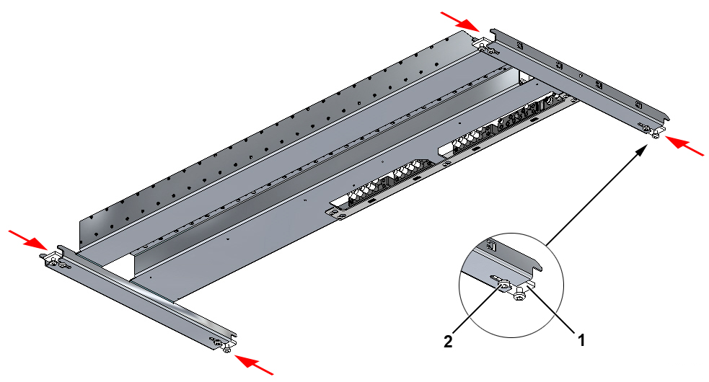
Fig. 1-5 Preparation of clock pulse unit for installation
1. | Fixing plate
2. | Guide screw, Torx 45, M8x16

.4 Install the clock pulse unit between the sorter section’s cable trays from below as shown in Fig. 1-6. Install the clock pulse unit from above if necessary for access reasons.
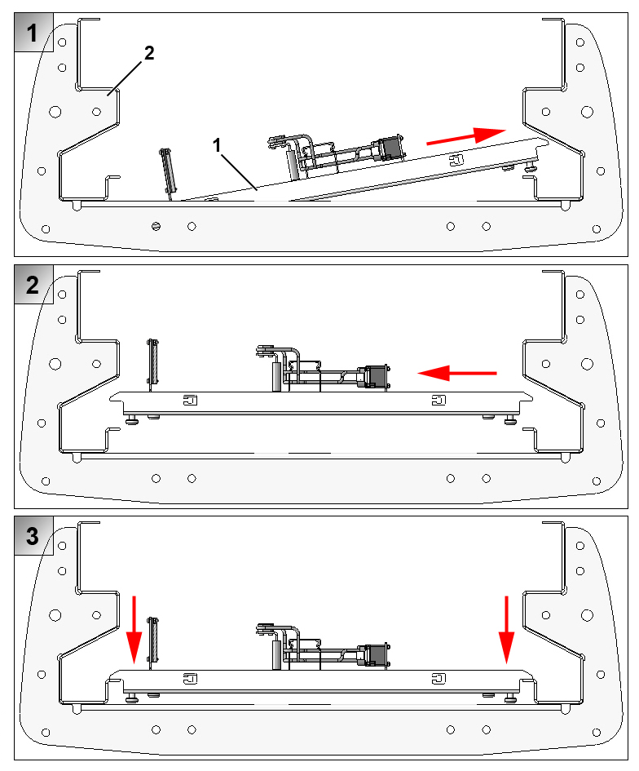
Fig. 1-6 Position of clock pulse unit in sorter section (as seen in direction of travel)
1. | Clock pulse unit
2. | Sorter section

.5 Push the four fixing plates in over the cable tray’s mounting flanges and tighten the four fixing screws and guide screws as shown in Fig. 1-7.
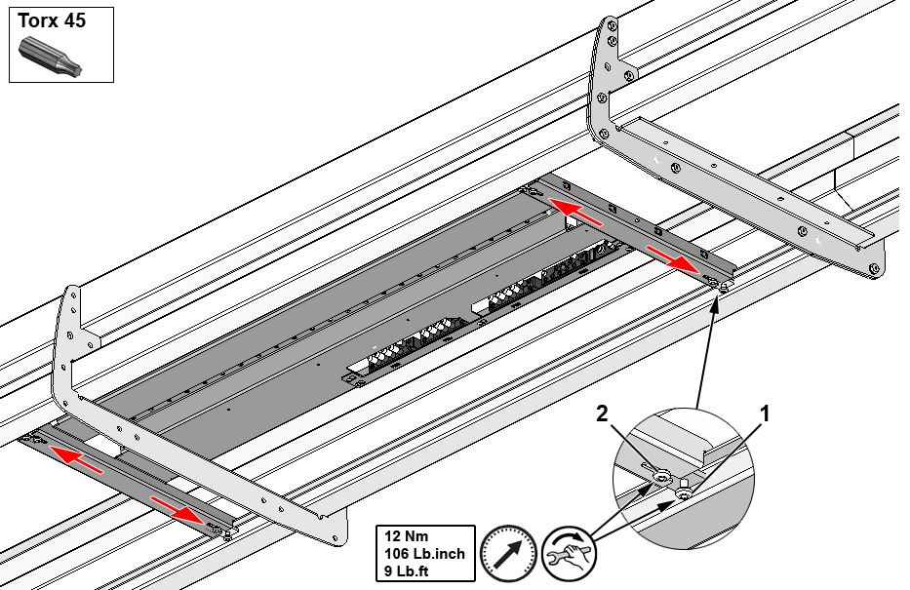
Fig. 1-7 Securing clock pulse unit
1. | Fixing screw, Torx 45, M8x16
2. | Guide screw, Torx 45, M8x16

Electrical connection

Profibus
Connect the clock pulse unit’s interface to Profibus with the two connectors provided, which can be found in a bag attached to the clock pulse unit.
Put the male connector on the incoming Profibus cable.
Put the female connector on the outgoing Profibus cable.
Connect the Profibus cables as shown in Fig. 1-8.
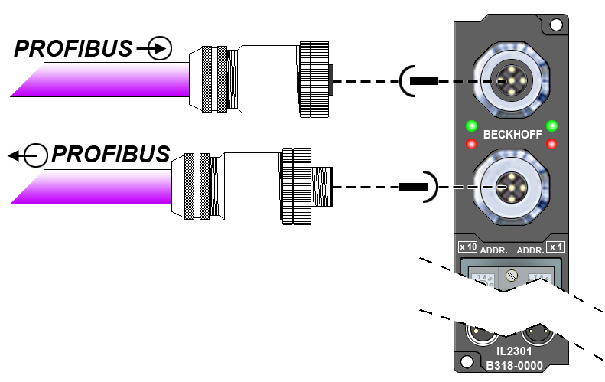
Fig. 1-8 Connecting Profibus
See also “Cable list for Profibus” when wiring Profibus.

Addressing
The Profibus address (network node number) is set using the two rotary switches located behind the transparent cover. The factory setting is 11. Any address is allowed, but each address must only be used once in the communications network. Change the address while the fieldbus module is disconnected.
.1 Loosen the screw and open the transparent cover.
.2 Use a screwdriver to turn the switches to the desired position. Make sure that the switch has engaged properly in the correct position.
.3 The left-hand rotary switch represents the tens (x 10), while the right-hand rotary switch represents the ones (x 1).
.4 The change of address will be activated as soon as the fieldbus module is connected.
Example:
The address needs to be changed to 34.
- Set the left-hand rotary switch to 3
- Set the right-hand rotary switch to 4
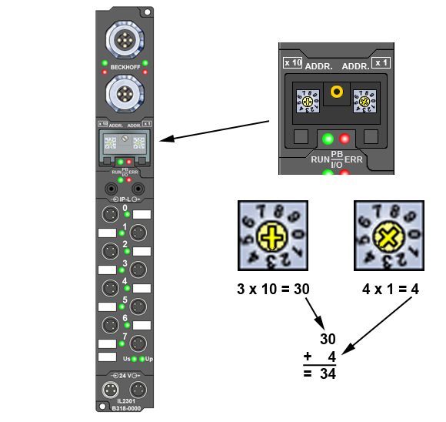
Fig. 1-9 Setting the network address

24 V supply
Connect the 24 V supply cables as shown in Fig. 1-10.
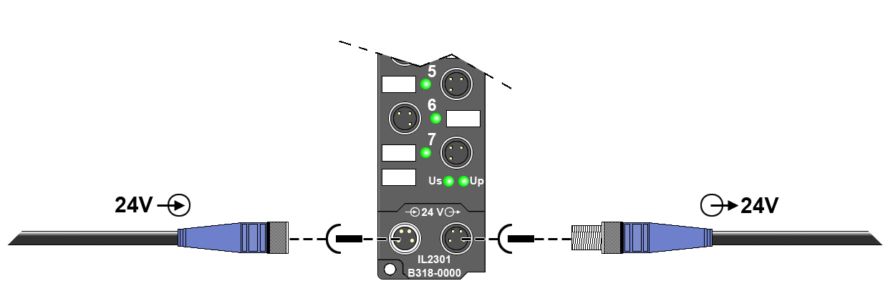
Fig. 1-10 Connecting 24 V supply cables
See also “Cable list for 24 V supply” when wiring the 24 V supply.

